Elizabeth Proctor
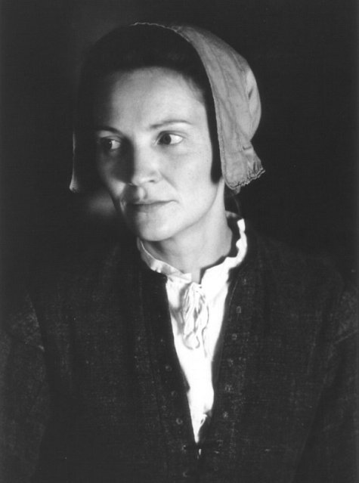

John Proctor

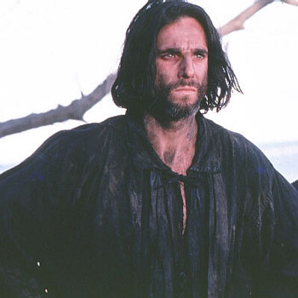

Abigail Williams (niece of Rev. Parris)

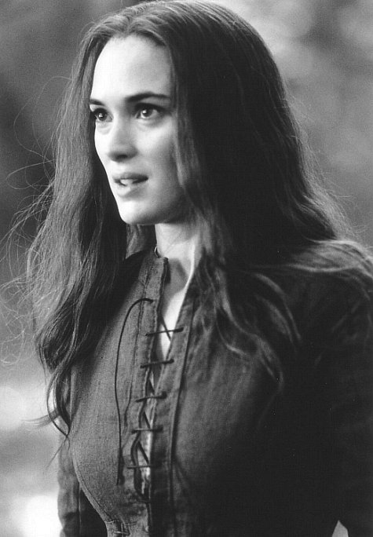

Reverend Parris

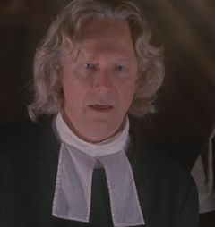

Betty Parris (daughter of Rev. Parris)

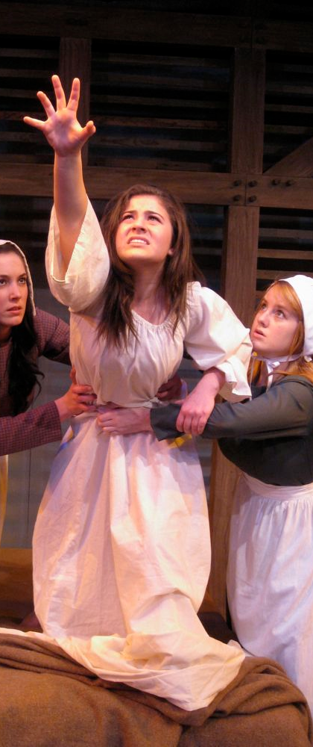

Tituba (from Barbados)

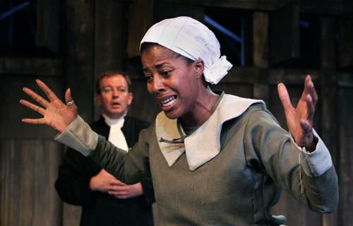

The Girls
Susana Walcott, Mercy Lewis, Mary Warren, others

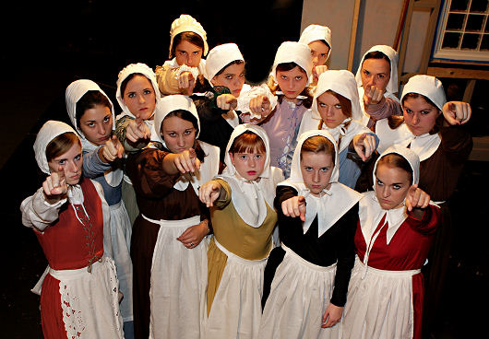

Mrs. Ann Putnam (married to Thomas Putnam, lost 7 babies)

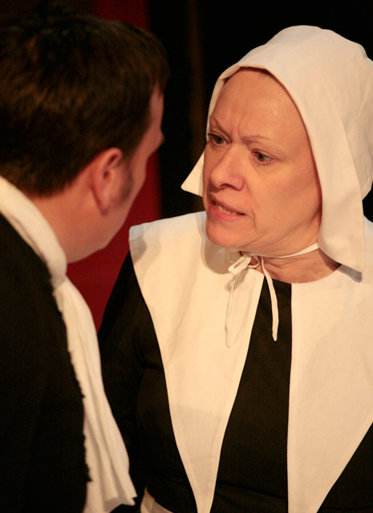

Mr. Thomas Putnam (Married to Ann Putnam, $)

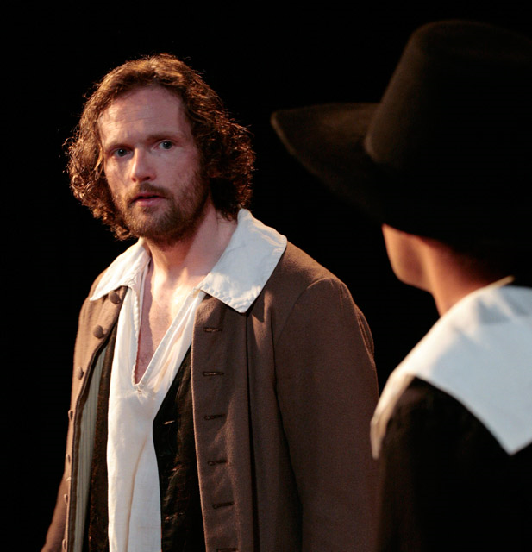

Rebecca Nurse (old, pious lady)

Giles Corey (silly old man who remarried)

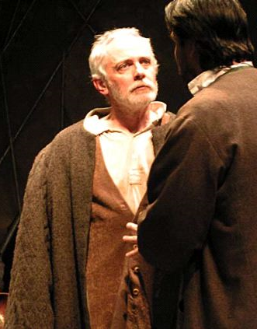

Reverend John Hale (witch hunter)

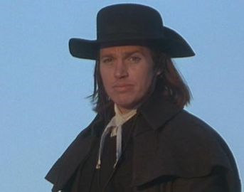

Francis Nurse (Rebecca’s husband)

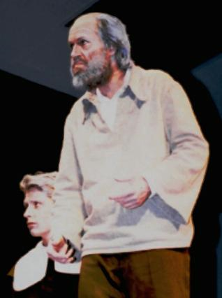

Ezekiel Cheever (gathering all of the accused)

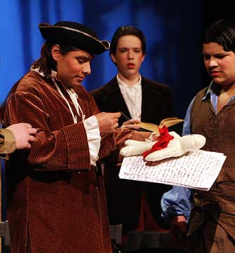

Judge Hathorne

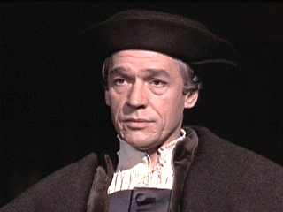

Deputy Governor Danforth

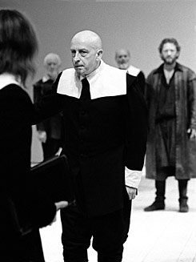

Sarah Good

