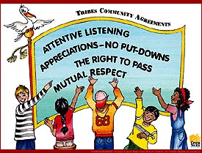
Classroom Form (Quarter 4) for Class Agreements, and Bathroom Passes
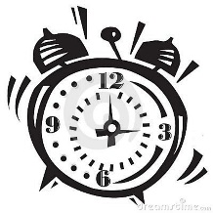

Direction: This form is the basis for Mrs. Averbach’s classroom management system. Every student needs to have this form available in the big black binder in the back of the room. No excuses!
Unexcused Tardies
Citation 1 | Citation 2 | Citation 3 | Citation 4 | Citation 5 | Citation 6
Free | In Class Citation | Student Reflection | Phone Call | Conference | Referral
Date | Date | Date | Date | Date | Date
Reason | Reason | Reason | Reason | Reason | Reason

Class Agreement Violations
Mutual Respect Appreciations/No Put-Downs Attentive Listening Right to Pass
Citation 1 | Citation 2 | Citation 3 | Citation 4 | Citation 5 | Citation 6
Free | In Class Citation | Student Reflection | Phone Call | Conference | Referral
Date | Date | Date | Date | Date | Date
Reason | Reason | Reason | Reason | Reason | Reason

Classroom Form (Quarter 3) for Class Agreements, and Bathroom Passes

Direction: This form is the basis for Mrs. Averbach’s classroom management system. Every student needs to have this form available in the big black binder in the back of the room. No excuses!
Unexcused Tardies
Citation 1 | Citation 2 | Citation 3 | Citation 4 | Citation 5 | Citation 6
Free | In Class Citation | Student Reflection | Phone Call | Conference | Referral
Date | Date | Date | Date | Date | Date
Reason | Reason | Reason | Reason | Reason | Reason

Class Agreement Violations
Mutual Respect Appreciations/No Put-Downs Attentive Listening Right to Pass
Citation 1 | Citation 2 | Citation 3 | Citation 4 | Citation 5 | Citation 6
Free | In Class Citation | Student Reflection | Phone Call | Conference | Referral
Date | Date | Date | Date | Date | Date
Reason | Reason | Reason | Reason | Reason | Reason

