What specific **aspects of the setting** (time, location) effects this character?

What **object** related to this character shows something about the character (possibly symbolism!)?

What does this character **think or** **say** that shows something about his character?

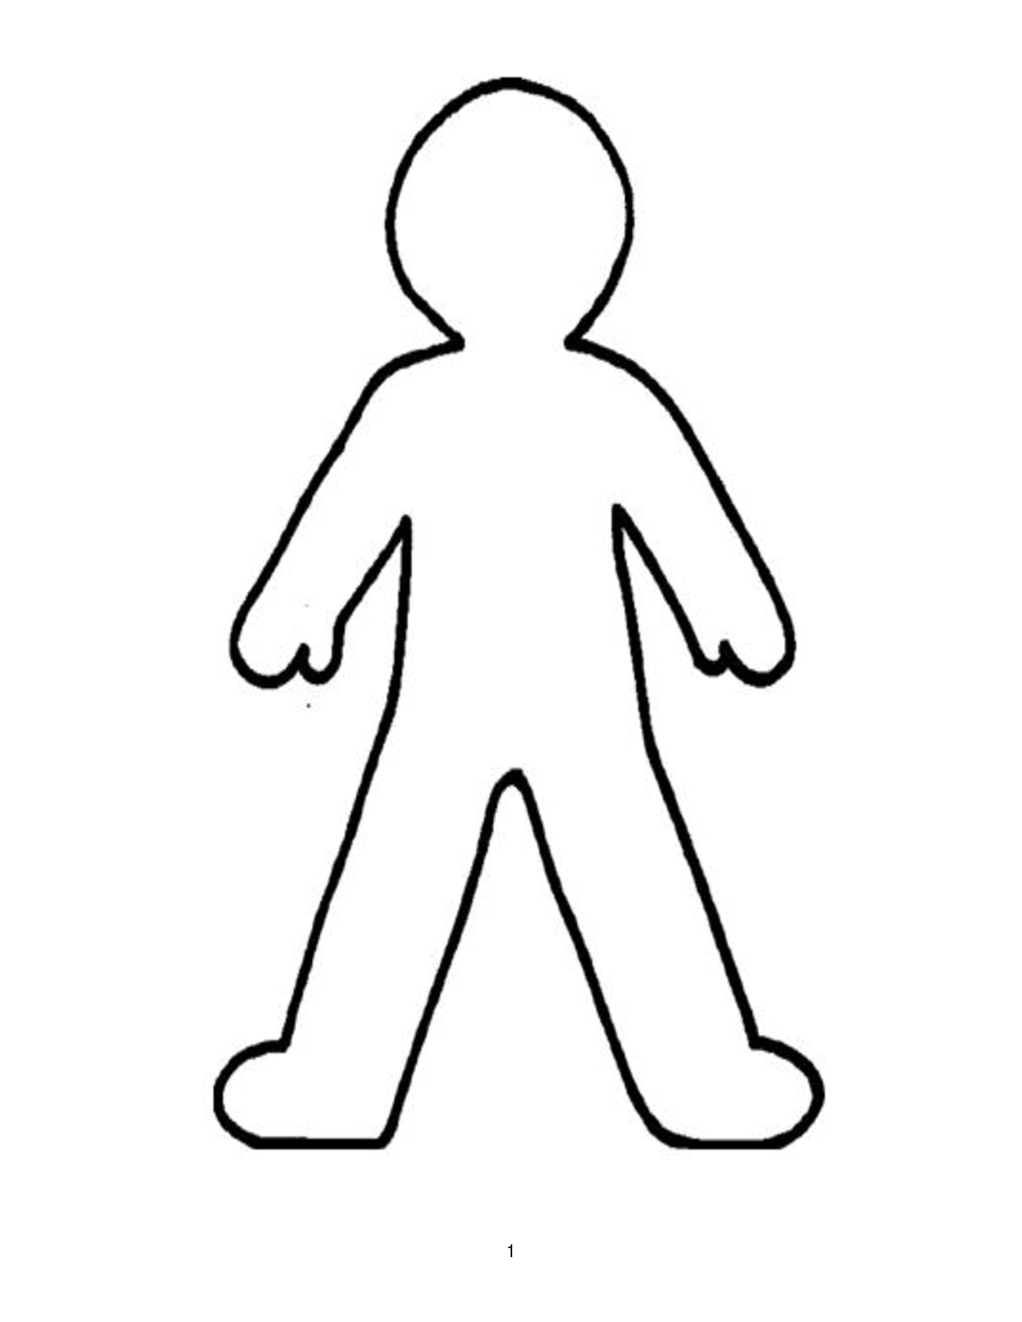

**GLUE this side**

**onto your Interactive Notebook**

**Cut along this line 🡪**

**Cut along this line 🡪**