Topic: Age of Revolution | Name:  Period:  Date:  Source: The Language of Literature Textbook, pgs. 256-258 & pgs. 260-261
Questions and Themes
Level 1: What is rhetoric? | American Revolution Rhetoric:
Level 2: What are examples of Amer. Rev. Rhetoric?
Level 3: What tone did Amer. Rev. Rhetoric have?
Level 4: How did Amer. Rev. rhetoric inspire colonists to act?
 | Things that strengthened colonists for revolution:
 | John Locke & his philosophy:
Pages 260-261 | Rhetoric:
 | Persuasive Rhetoric
 | Logical Appeals (Logos):
 | Emotional Appeals (Pathos):
 | Ethical Appeals (Ethos):
 | Styles of Persuasion:
 | - Elevated Language:
 | - Rhetorical Questions:
 | - Repetition (parallelism):
Practice with Appeals
Directions: Point out the persuasive appeals used in the quotations from the period of the American Revolution below.

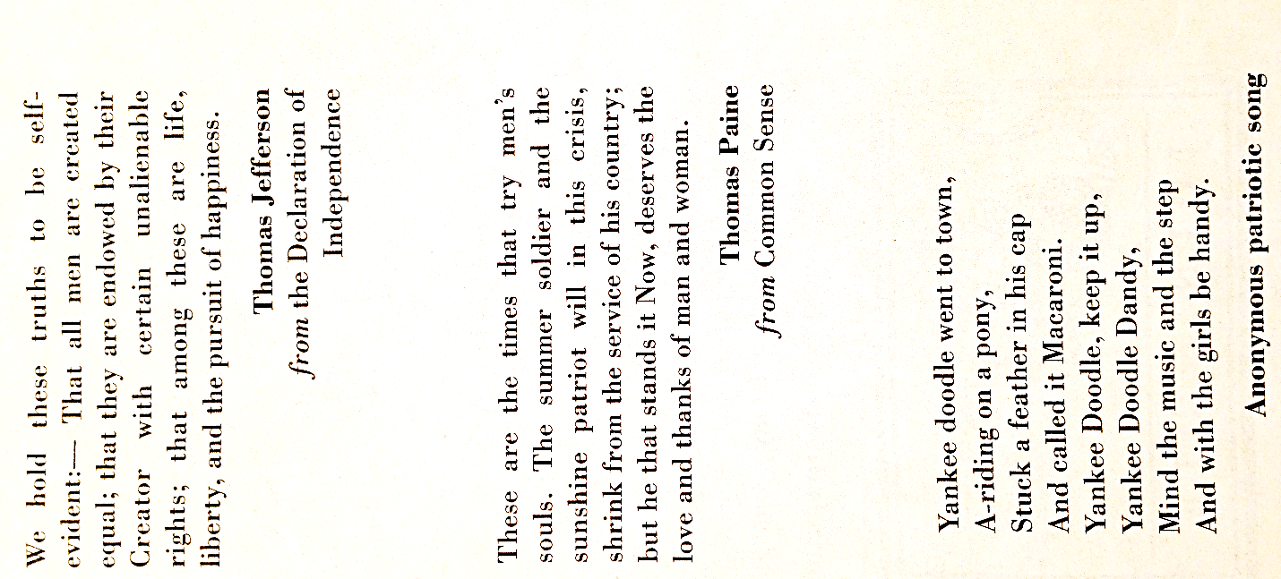
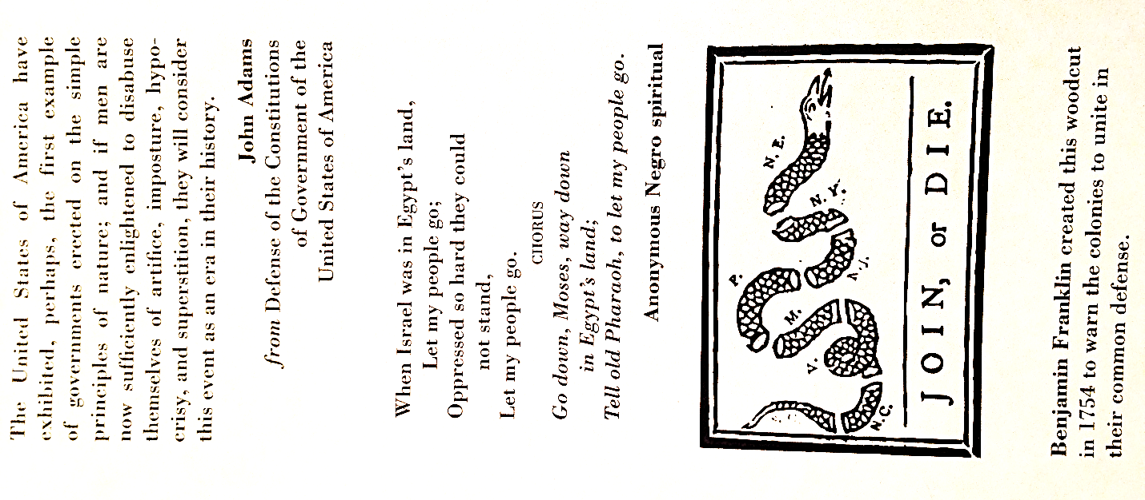

2-3 Sentence Summary about the American Revolution:

