ACTIVE READER
Page & Line | Quotation | Explanation
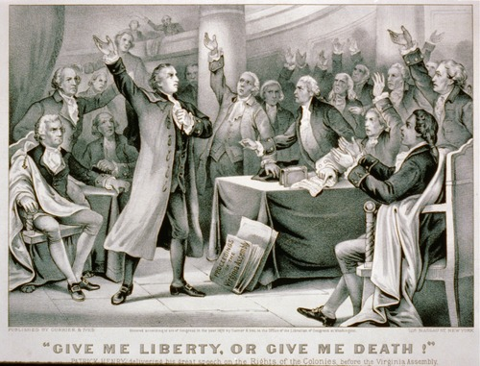
What do you notice about the expressions on the people’s faces in this scene? Is everyone in agreement with Patrick Henry?

Think Tank
Directions: In groups of 3-4 people, come up with as many examples and answers to the following questions as your group can uncover.
(4) Why does Henry say “Their clanking may be heard on the plains of Boston!” What event is he talking about?

(3) Why is Henry provoking his audience in lines 57-73?

(2) What emotions is Henry trying to evoke through rhetorical questions in lines 38-40? What logical argument is he making?
(1) Why might Henry have chosen to use the biblical allusion on lines 34-35?

